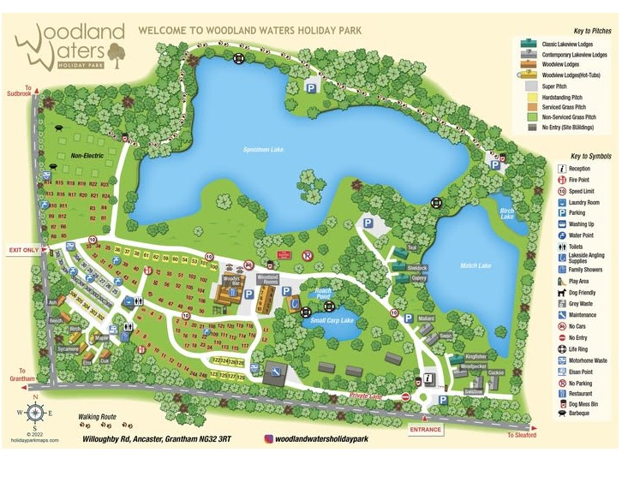
National AGM Romaclub Rally.
29th May—
1st June 2026.
Woodland Waters.
Willoughby Road,
Grantham, NG32 3RT.
BOOKING FORM. Final Date for booking—1st May.
Roma Club National AGM Rally.
Friday 29th May—Monday 1st June 2026.
Woodland Waters, Willoughby Road,
GRANTHAM, NG32 3RT.
Membership Number …………………
First person. Full Name …………………………….………………..
Second Person. Full Name ...............................................
Address: …………………………………………………………………..………………………………………………………..............................
Post Code.......................Telephone number:………………....
Email:…........................................................................
Pitch with EHU. £32.00 p/night
No. of nights …...@ £32.00 £…….…..…..
No EHU £28.00 p/night.
No. of nights .....@ £28.00 £……….……..
Total Remittance: £…..……….…
Please help us by making a BACS payment please
sort code 30.97.21 account 00393737
Then post or email completed form to - Anne Graystone,
31 Clifton Street, May Bank, Newcastle under Lyme, Staffs. ST5 0JL. email despatchandlabels.romaclub@gmail.com
If unable to pay by bank transfer you may post this form with a cheque payable to “Romaclub” to Anne at the above address.
Special Needs.:- Please state. (e.g. Not near dogs, near a friend, near toilets.)
..................................................................................................
Registration Number……………………site has number plate recognition.
Hook ups are limited so if you need one for health problems, please advise.

